MAILBOX ALERT SYSTEM

Use Case Specification: Sending SMS

Version 1.0

Revision History

|  |  |  |  |
| --- | --- | --- | --- |
| **Date** | **Version** | **Description** | **Author** |
| 30/03/2017 | 1.0 | Sending SMS | K.Sriram  N.Vignesh  J.Sachin Fernandez |
|  |  |  |  |
|  |  |  |  |
|  |  |  |  |

Table of Contents

1. Use Case Name 3

1.1 Brief Description 3

2. Flow of Events 3

2.1 Basic Flow 3

2.2 Alternative Flows 3

2.2.1 < First Alternative Flow > 3

2.2.2 < Second Alternative Flow > 3

3. Special Requirements 3

4. Preconditions 3

5. Post Conditions 3

6. Extension Points 3

Use Case Specification: Sending SMS

# Sending SMS

## Brief Description

The purpose of this use case specification is to send the alert message once a letter is received in the letter box. Once when the letter is fed into the letterbox, the photo resistor fluctuates in the signal. This fluctuation in the photo resistor is sent as a signal to the GSM Module through an Arduino UNO medium and the alert message is sent to the resident.

# Flow of Events

## Basic Flow

The purpose of this basic flow is to send Short Messaging Service (SMS), once a letter is dropped in the letterbox. The alert message is sent by the device named GSM Module. 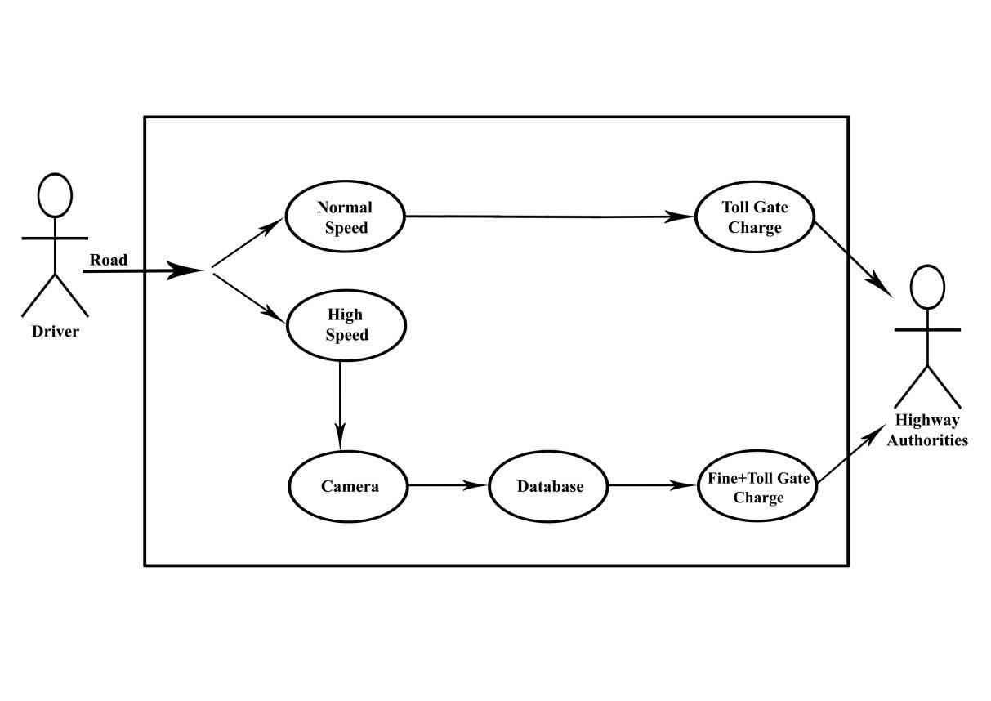

## Alternative Flows

### < First Alternative Flow >

#### < An alternative sub-flow >

### < Second Alternative Flow >

# Special Requirements

GSM MODULE – GSM networks operate in a number of different carrier frequency ranges (separated into GSM frequency ranges for 2G and UMTS frequency bands for 3G), with most 2G GSM networks operating in the 900 MHz or 1800 MHz bands. Where these bands were already allocated, the 850 MHz and 1900 MHz bands were used instead (for example in Canada and the United States). In rare cases the 400 and 450 MHz frequency bands are assigned in some countries because they were previously used for first-generation systems.

# Preconditions

First Priority for this project is Photo resistor which detects whether a letter is received or not.

The signal is been send by photo resistor to GSM Module and sent to the resident.

# Post Conditions

The detecting of letters in the Mailbox and transmits the alert message through the module.

# Extension Points

Going to provide details about the letter received.